Smears and Cancer care Workbook

Label the diagram:
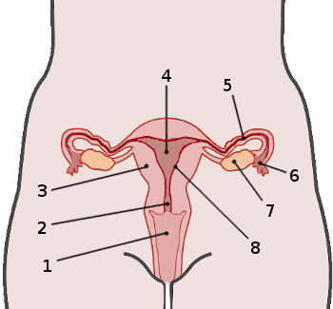

Read through the OSCE guide on smear taking:
Cervical Screening Test - OSCE Guide | Smear | Geeky Medics

Answer the questions:
- What is the purpose of the smear?

- Why is informed consent important?

- List the equipment used for the smear…

- How often do women have smears?

- List some reasons why women may not come for a smear?

- What safeguarding considerations would you need to think about when observing a smear?

- What is the smear looking for?

- If a woman was 52, how old would she be at her next smear?

- If a patient has had a total hysterectomy with removal of the cervix- does she need a smear?

- How do women receive the results for a smear?
Complete the word search:

Cancer care-

- In primary care we often care for patients with prostate cancer using zolodex injections.
Look up Zolodex injection in the BNF or BNF online and answer the questions:
- What is the generic drug name?
- What is the main purpose of the drug?
- How is the drug administered IM or IV or SC?
- What is the dose for an adult and how often?
- Is there any other uses of the drug other than prostate cancer?
- What are the common side effects of this drug?

- What cancer services are offered to patients in the UK?
- List some charities that support patients with cancer.

- How can you as a student support patients with cancer?

- What treatment options are available for patients with cancer?
List 5…

- What self-care recommendations are advisable for patients living with cancer?

- What increases your risk of lung cancer, breast cancer or bowel cancer?
- Pick on and list the risk factors.

Reflections:
Write a short reflection using a GIBBS cycle on caring for a patient with cancer or observing a smear test. If you don’t have one- please find a scenario online to reflect on.

Lastly: Read this article relating to smear taking and make notes for discussion in the session.
Knowledge about Cervical Cancer and Pap Smear and the Factors Influencing the Pap test Screening among Women (nih.gov)

