Wound care work sheet
IPL

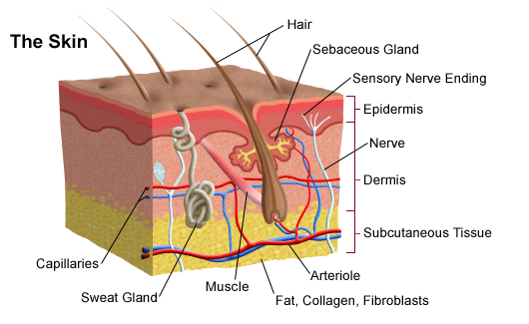

Can you list some common wounds you would see in primary care?

- Burns:
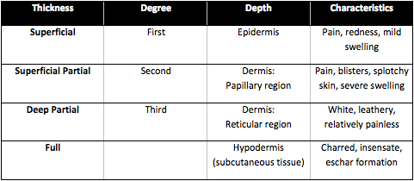

Can you bullet point the first aid protocol for a burn?

What other things must you consider with burns?

- Pressure Ulcers:
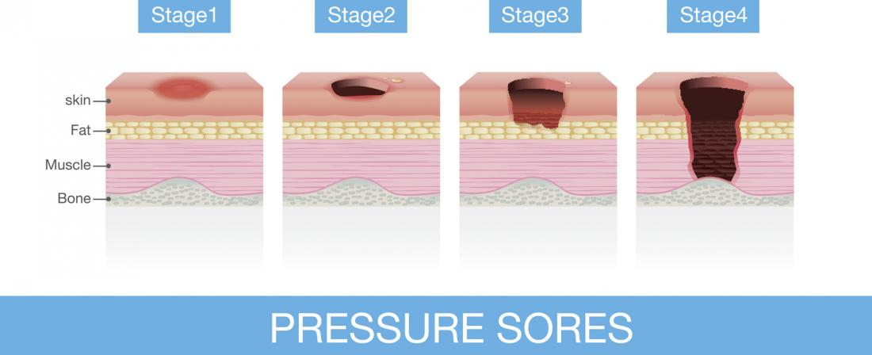

Would you consider safeguarding if you had a patient with a new onset of pressure ulcer?

Can you list any dressings or products that may aid pressure ulcer management?

Who would you contact if you were concerned about a pressure ulcer?

- Leg Ulcers:
List as many leg ulcer dressings that you can think of and their purpose:

What are some common causes of leg ulcers?

What are some reasons leg ulcers may not heel?

If I want to put someone in compression bandaging- what would I need to do first?

- Removal of sutures-
How long sutures should be left in?

What should you be looking for before removing sutures?

- Wound assessment:
Note down what questions you would ask a patient who attended with a new wound for dressing:

Note down some observations you would make when you are examining the wound:

- Reflections:
Write a brief reflection on a wound care scenario you have been involved in:
How did you feel- was it tiring?
What did the wound look like, were there any concerns?
How did the patient seem was it painful?

- Read the article and make notes for discussion in the session: https://www.independentnurse.co.uk/clinical-article/wound-assessment-and-treatment-in-primary-care/116877/

A
Aetiology
The science, doctrine, or demonstration of causes; esp., the investigation of the causes of any disease; the science of the origin and development of things
Acute
An acute wound is one in which healing occurs as a sequential cascade of overlapping processes that requires the coordinated completion of a variety of cellular activities. These processes are not haphazard but carefully regulated
Aerobic bacteria
Aerobes are bacteria which require the presence of molecular oxygen
Anaerobic bacteria
Anaerobes are bacteria that do not tolerate free oxygen and grow where there is no air or where there is a low oxidation-reduced potential
Angiogenesis
The generation of new blood vessels initially seen at the base of the wound
Ankle flare
Distension of the small vessels which appears around the ankle and heal and is associated with venous hypertension and venous ulceration
Autolysis
The breakdown of devitalised tissue by leucocytes

C
Chronic
A chronic wound is one in which the normal process of wound healing is disrupted at one or more points in the phases of wound healing. Often a chronic wound is ‘stuck’ in either inflammation or proliferation. These wounds are often impeded by the accumulation of necrotic or sloughy tissue in the wound bed
Collagen
A protein generated by fibroblasts which provides the supportive network of connective tissue
Connective Tissue
Contains collagen and elastic fibres and can be found in the dermis

D
Delayed primary closure
An anatomically precise closure that is delayed by a few days but before granulation tissue becomes visible
Dermis
This is second principal part of the skin and is composed of connective tissue. The few cells in the dermis include fibroblasts and macrophages.The thickness of the dermis varies depending on anatomical location. Blood vessels, nerves and glands are embedded in the dermis

E
Epidermis
This is the first layer of the skin and is composed of stratified squamous epithelium and contains four principal cells, the main cell being the keratinocyte. These cells help waterproof and protect the skin and underlying tissues
Epithelium
The cellular covering of internal and external body surfaces, including the lining of vessels and small cavities
Erythema
A painful spreading redness around a wound
Extracellular Matrix
Consists of ground substance and fibres. The ground substance is an amorphous gel like material that fills the spaces between cells and contains interstitial fluid and proteoglycans. The fibres consist of collagen, elastin and reticular fibres
Exudate
This is fluid that accumulates in a wound.
- Sanguineous: Bloody.
- Serous: Clear or pale yellow.
- Serosanguineous: Serous with hints of blood.
- Purulent: Green, brown or yellow pus.
- Scant: Tiny amount of fluid noticed when changing dressing.
- Minimal: Exudate is present on about one-third of dressing surface.
- Moderate: Exudate covers less than two-thirds of dressing surface and may soak through.
- Large: Exudate covers more than two-thirds of dressing surface and likely soaks through.

F
Fibroblast
The cells that form fibrous tissue

G
Growth factors
Peptides which are a subset of cytokines vital for cell proliferation

H
Haemostasis
The stoppage of bleeding

M
Maceration
A softening or wetting of the skin owing to retention of excessive moisture
Macrophage
Phagocytic cell derived from a monocyte

N
Neuroischaemia
The neuroischaemic foot is cool, pulseless with poor perfusion associated with peripheral neuropathy. The foot may appear deceptively pink or red
Neuropathy
The neuropathic foot is a warm, well perfused foot with bounding pulses, sweating is diminished and the skin may be dry and prone to fissures. Callus may be present which is hard and dry. The arch of the foot tends to be raised and the toes may be clawed
Neutrophil
A type of white blood cell characterised by granular cytoplasm

P
Primary Intention
When the edges of a wound are approximated and the individual layers of tissue are joined together by suturing, staples or tissue adhesives or a combination of all of these
Protection
The skin covers the body and provides a physical barrier that protects underlying tissues from physical abrasion, bacterial invasion, dehydration and UV radiation

R
Regulation
The skin regulates temperature by the use of sweating and changes in the blood flow when exposed to extremes of temperature, high or low

S
Sensation
The skin contains abundant nerve endings and receptors to detect stimuli related to temperature, touch, pressure and pain
Secondary Intention
When a wound has sustained a degree of tissue loss it may seem impossible to close the wound as the edges cannot be bought together or undesirable if infection is still present
Skin
The skin is a large organ covering the whole body, it serves as an organ of protection and regulation
Slough
Slough is a consequence of the inflammatory phase of wound healing. It comprises dead white blood cells, fibrin, cellular debris and liquefied devitalised tissue. In acute wounds, neutrophils remove dead and devitalised tissue and ingest debris and bacteria.
Subcutaneous fatty tissue
This layer lies beneath the dermis and contains areolar and adipose tissues

