Integrated professional learning (IPL)
Welcome to the IPL teaching sessions. As there are different groups starting at different times the introduction session for IPL may not be at the start of your placement and may fall a few weeks in. Therefore I would like to welcome you to your IPL sessions in advance and give you this worksheet to bring to your session date detailed in the email. Upon completing this worksheet I look forward to following up and going through answers
What is IPL?
‘Interprofessional education occurs when two or more professions learn with, from and about each other to improve collaboration and the quality of care’.
(UK Centre for the Advancement of Interprofessional Education)
- For example a nurse in primary care has an appointment with a patient coming in for a wound dressing. This patient has disclosed to the nurse that they are struggling with the activities of daily living at home. The nurse notices that this patient is unable to mobilise from the waiting room to the clinical room without using the wall for support. As the nurse has engaged in IPL they have an understanding of the multiple roles involved in the community multidisaplinarary team and they are able to facilitate care for the patient using this knowledge.
A. Occupational therapists to assess at home needs.
B. District nurses to attend the patients’ home for wound dressing.
C. The tissue viability nurse in the community to assess the wound healing.
D. The general practitioner may need to organise a health check for the patient.

Can you think of any other members of the team who may be able to help our patient?

Overall the increase and knowledge regarding IPL increases the ability to facilitate patient centred care- resulting in improved patient experience and health outcomes.
For this first session the aim is to gather feedback on your understanding of IPL and your role within the multidisaplinarary team. This will aid the structure of on-going sessions and mean we can tailor them to your interests/ potential gaps in knowledge.
Please answer questions in as much detail and elaborate where possible.
- Can you list as many members of the multidisaplinarary team as you can?

- What is your role within the multidisaplinarary team?

- Are you affected by your fellow team members roles within your practice? How?

- Can you identify any gaps in knowledge within primary care you would like addressed in IPL sessions?

- Can you list the benefits and draw backs of Interprofessional learning?

- Do you think there is value in inter-professional learning?

- Can you describe anonymously a time where you have experienced a care giving situation where you have engaged with different professions?

- How do you debrief/ de-stress?

- What do you understand about emotional intelligence within the team and how do you support each other? Does this apply to just your discipline or do you seek support from other members of the multidisaplinarary team?

- Can you tick from this list any sessions that would be of interest to you and add on any extra subjects you would like me to cover in the IPL sessions?
Cardiac care in primary care
COPD and Asthma in primary care
Wound care
Doppler
Diabetes
History taking
Vaccinations
Reflections in practice
Service provision
Abdominal pain
Ankle sprains
Smears
Musculoskeletal injuries
Ear/nose and throat conditions
Health promotion- NHS health checks

- https://www.nursingtimes.net/roles/nurse-educators/how-interprofessional-learning-improves-care-24-05-2013/

Please read this article on Interprofessional learning and make notes on anything that is highlighted to you/ any thoughts for discussion in the introduction session.

Write a reflection on a time where you have utilised a colleague’s expertise and worked together with a different profession to achieve a common goal- use a Gibbs cycle for your reflection and pay particular attention to thoughts/feelings behind the scenario. This can be as a student or an event in a previous job/ in school.
- What did you learn from your colleague?
- What did your colleague learn from you?
- Is this helpful? Is there value in it?

Reflective practice worksheet

- In the box below use Gibbs reflective cycle to write a short reflection of something experienced in practice.

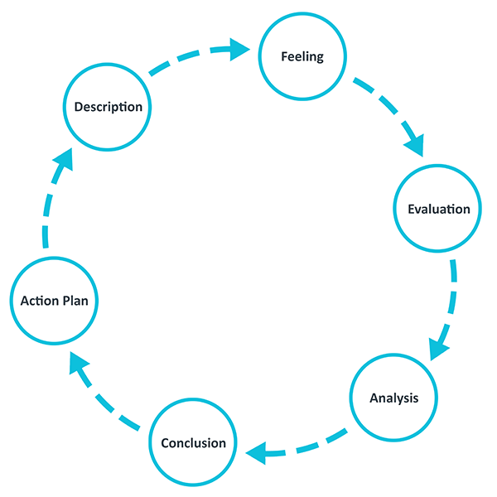

- Answer the questions below…

- What key things did you take away or learn from this experience/feedback?

- How did you address any issues or problems that arose?

- What would you do differently, if anything, next time around?

- How has it impacted on your practice?

- Are there any changes you can quickly apply to your practice?

- Are you able to support yourself and other colleagues better?

- What can you do to meet any gaps in your knowledge, skills and understanding?

- Do you think emotional intelligence is an important factor to reflect on?

- Can you identify any feelings behind actions you made?

- Do you think different professions reflect differently? E.g., Doctors/nurses/physiotherapists.

- Can you think of any pros and cons of reflective practice?

- Can you think of any barriers of reflective practice?

Finally read and make notes on the article link: https://journals.lww.com/ijsoncology/Fulltext/2017/07000/Reflective_practice_in_health_care_and_how_to.2.aspx

