IPL Eye conditions

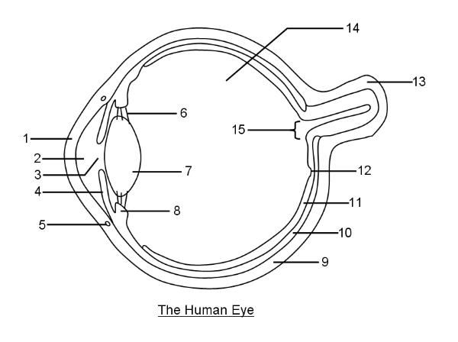
Label the diagram-

1.
2.
3.
4.
5.
6.
7.
8.
9.
10.
11.
12.
13.
14.
List the function of each of these structures
1.
2.
3.
4.
5.
6.
7.
8.
9.
10.
11.
12.
13.
14.

Lable the outer eye diagram:
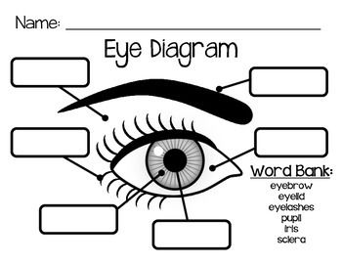

Name 3 common eye conditions that would affect the outer eye and the treatment options…

Discuss 3 some activities of daily living that would be affected by blindness.

Scenario one- Lilly is 82 years old, she is blind and has lived alone for the last 8 years after her husband suddenly passed away. She had a fall yesterday and sustained a small wound to her arm which the nurse is dressing 2 times a week. Lilly has a guide dog and has coped well at home prior to this. What considerations would you make for Lilly? What would you want to check or what questions would you want to ask? Would you need to refer her to anyone?

Scenario two- Rob is a plasterer- he has attended the GP surgery with a feeling of something in his eye. His vision is blurred, he is in 8/10 pain, his eye his sclera is red and his eye is watery.
What could have happened to Rob?

List the first aid procedures for a chemical burn.

When do we need to refer Rob on- what would prompt a referral?

Reflection-
Have you been involved with treating someone with an eye condition? Or for yourself or a family member?
Use a Gibbs cycle to write a reflection on this-

Lastly read the article on eye conditions: https://www.nursingtimes.net/clinical-archive/assessment-skills/principles-and-procedure-for-eye-assessment-and-cleansing-28-11-2019/

