How to write a Reflection.

Writing Reflections is an important aspect of your placement at KEC, partly because Reflections are an effective learning tool in their own right, and partly because they are preparation for the Professional Resilience Training later in your placement. But they are also important because, when you come to re-register, you will be required to submit a number of reflections and so these exercises during your time with us are practice for your future.
When Completing a reflection:
Read the instructions carefully. Twice is good practice, (including the timescale for submission).

Watch any links.

Create a Word document.

Write your name, the title and date.

Write the reflection using headings, eg:
- Introduction
- How the patient presented.
- How the issue was resolved (including what you did).
- What you learned and what could have been done better

Consider using Gibbs Reflective Cycle:
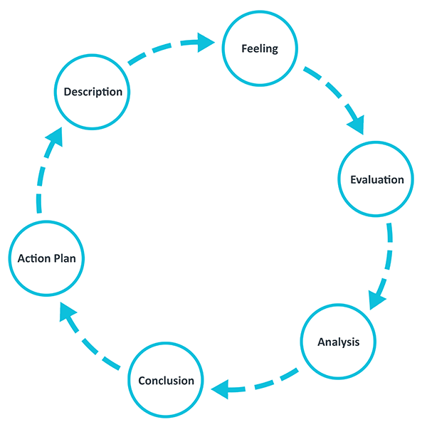

Read through your work. Check you have answered the question, check you have written enough, (500 words).

Correct any typos, spelling, grammar.

If you have read around the subject, attribute any references to avoid plagiarism.

If you are unsure about what is required, ask.

Ensure you are happy with what you have written. Submit it in time.

Nick Cornish

